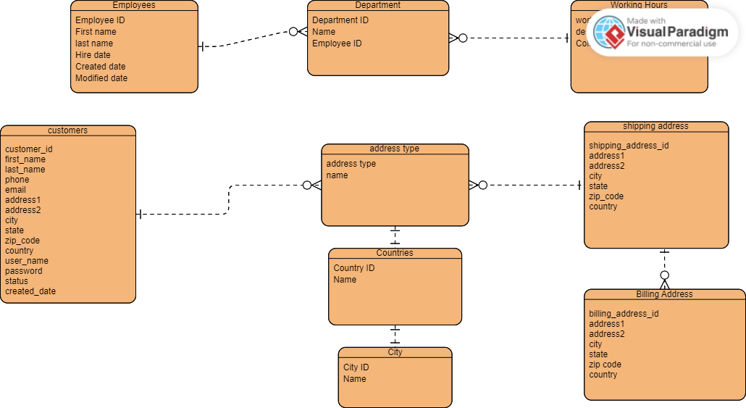



**BACCHUS WINERY BUSINESS RULES**

* All finances and payroll are handled by Janet Collins
* Marketing inquires are handled by Roz Murphy and Bob Ulrich
* Production line/employees handled by Henry Doyle
* Distribution inquiries handled by Maria Costanza
* All Wines use Bacchus Winery grapes
* One distributer provides all bottles and corks
* One distributor provides all boxes and labels
* One distributor provides all vats and tubing
* All distributors ship components once a month
* Stan and Davis track all supply inventory